|  |  |
| --- | --- |
| 932347227 | https://www.ryhxgy.cn/EN/2097-2806/home.shtml |

Go to the website using the based URL.

Capture volume

Capture year

Capture month

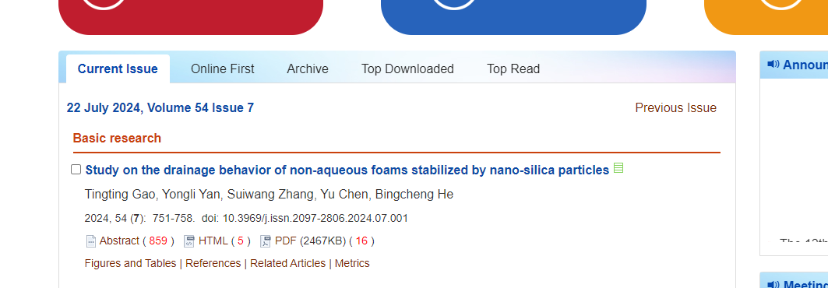

Click here to download

Capture page range

Capture DOI

Capture title

Capture issue

Capture date

Need non roman and English TOCs